**UML Diagram**

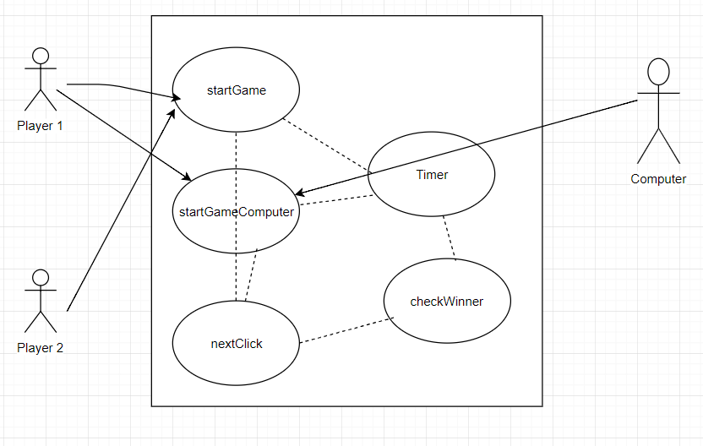

**Analysis:** Below is the thought process I had once I read the requirement document.

1. Need a table in html page, this is where the game happens.
2. A very basic css which is clean.
3. Javascript file linked to html file and needs to be triggered as soon the user clicks the cell.
4. So, now in the javascript file, I need to first create a function to handle the clicks given in each cell of the table.
5. I need to toggle between X and O for each click.
6. I need to randomize who needs to play first.
7. I need to get the timer start as soon as the player clicks on one of the cells.
8. For each click I need to check who the winner is.
9. Messages needs to be displayed for each click/cats game and winning situation including the timer time.
10. Start/restart and playagain buttons need to be made.

**Solution to the above problems:**

I have started the project by creating a very basic html page which has the table and heading saying tictactoe and made a relevant css page accordingly.

I have started the javascript file writing the start game function first which gets loaded as soon as the html page loads. Then have started working on the NextClick() function which gets triggered when a user clicks on the cell of the table and this function triggers checkWinner() function for every click event, this function checks who the winner is and displays the time taken to complete the game. Once this is done I have worked on the messages.

Now, I have included the randomization of the selection in the startGame() function and then started working on startGameComputer() function. This function is loaded as soon as the user selects player vs computer. This function triggers nextClick() function where I have now included the logic for the computer to select the available cell and the remaining procedure is the same.